CNS
Unit – 6

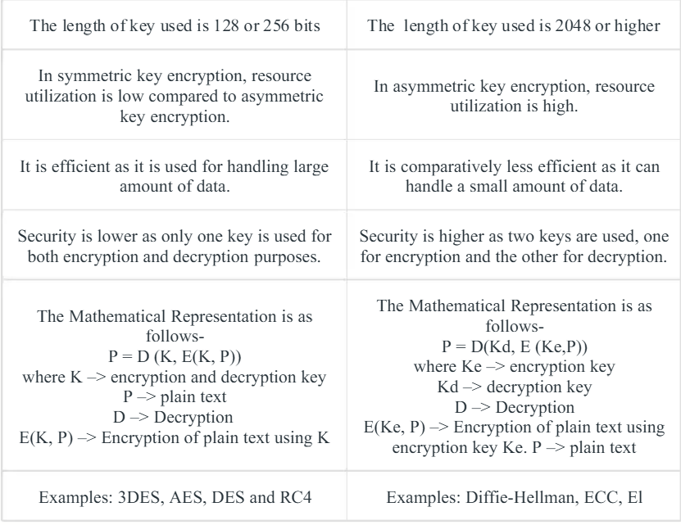
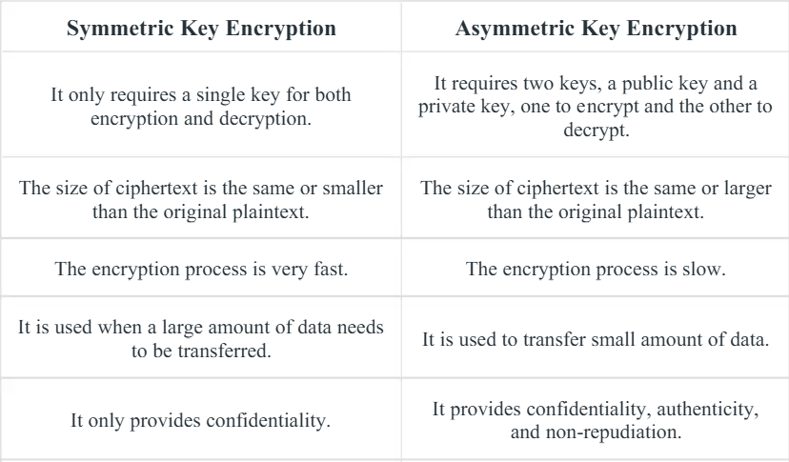
Q. Differentiate between Symmetric and Asymmetric Key Cryptography
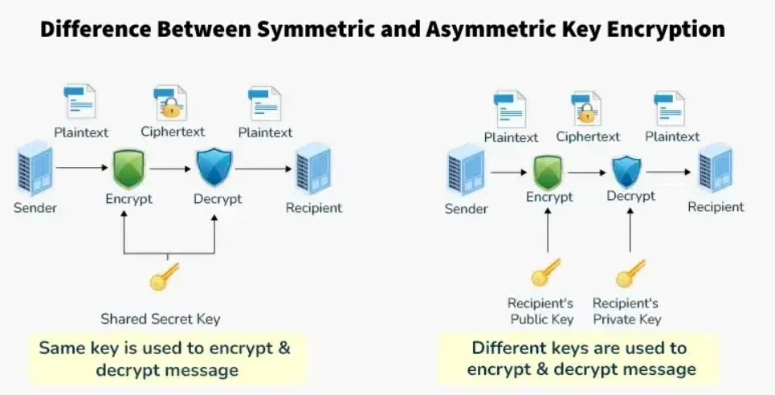

Q. Explain SSL in detail
SSL (Secure Sockets Layer) is a security protocol that encrypts data between your browser and a website, creating a secure, private link (HTTPS) to protect sensitive info like passwords and credit cards from hackers, using digital certificates for identity verification and handshakes to establish trust before scrambling data with public/private keys. Though outdated, "SSL" is still used for its modern successor, TLS (Transport Layer Security), which provides privacy, authentication, and data integrity for online communication.
What SSL/TLS Does (Simple Explanation)
Imagine you're sending a secret note to a friend in a locked box.
- Locking (Encryption): You and your friend agree on a secret code (keys) to lock and unlock the box. Only you two have the keys.
- Checking ID (Authentication): Before exchanging, you both show ID to prove you are who you say you are (SSL Certificate).
- Secure Delivery: You put the note in the box, lock it, and send it. Even if someone intercepts it, they can't open it.
How it Works (In More Detail)
- Handshake: When you visit an HTTPS site, your browser and the server perform a "handshake":
  - Server sends its SSL certificate (ID) to your browser.
  - Browser verifies the certificate with a Certificate Authority (trusted third party).
  - Browser and server agree on encryption methods and generate a temporary, shared secret key for the session.
- Encryption: All data (login info, payments) is encrypted using this shared key before being sent and decrypted upon arrival, making it unreadable to eavesdroppers.
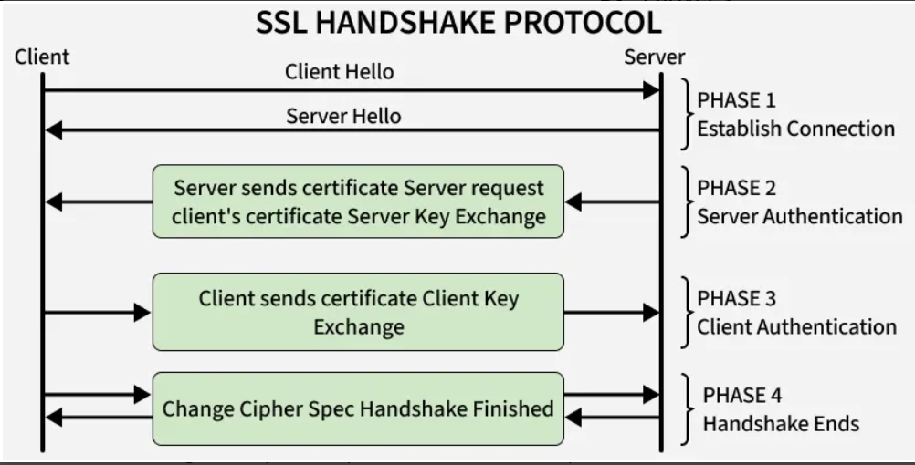
- HTTPS: The 'S' in HTTPS stands for Secure, indicating SSL/TLS is active, shown by a padlock icon in your browser.

Key Benefits
- Confidentiality: Prevents data snooping.
- Authentication: Ensures you're talking to the real website, not an imposter.
- Data Integrity: Guarantees data isn't altered in transit.
SSL vs. TLS
- SSL is the original protocol (Netscape, 1995).
- TLS (Transport Layer Security) is the updated, more secure version that replaced SSL.
- Today, when you see "SSL," it almost always means TLS is actually being used.

Q. Give short note on Firewalls.
A firewall is a network security barrier, like a digital security guard, that monitors and controls incoming/outgoing traffic between a trusted network (your computer/company) and untrusted networks (the Internet) based on set rules, blocking threats like hackers and malware while letting safe data pass, preventing unauthorized access and protecting sensitive information. It works by inspecting data packets, deciding to allow, deny, or drop them, and can be software, hardware, or both.
How it works (Simple Analogy)
Imagine a bouncer at a club:
- You (Internal Network): The party inside.
- The Internet (External Network): The street outside.
- The Firewall (Bouncer): Checks IDs (rules) for everyone trying to get in or out.
- Data Packets (People): Data trying to enter or leave.
- Rules (Guest List/ID): Tells the bouncer who is allowed (safe traffic) and who isn't (hackers, viruses).
Key Functions
- Blocks Unauthorized Access: Stops intruders from getting in.
- Filters Malicious Traffic: Catches viruses, phishing, and attacks.
- Protects Data: Prevents sensitive info from leaking out.
- Content Control: Can restrict website access (e.g., parental controls).
Types (Simplified)
- Packet Filtering: Checks basic info (address, port) of each data packet.
- Stateful Inspection: More advanced, tracks the "state" of connections.
- Next-Generation Firewalls (NGFW): Combines traditional firewall features with other security (like intrusion prevention).

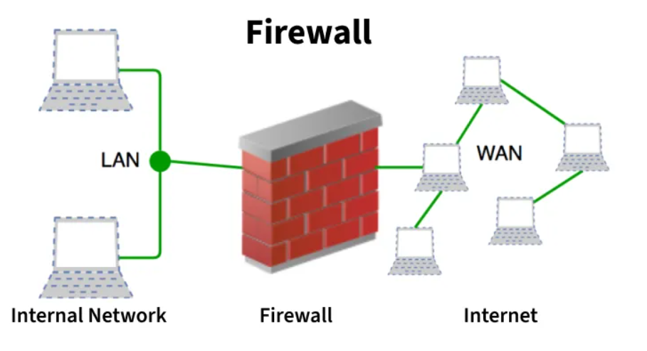
Q. Draw and explain ITU-T X.800 Security Architecture for OSI.
The ITU-T X.800 Security Architecture provides a standard framework for security in the 7-layer OSI model, focusing on Security Services (like Confidentiality, Integrity, Authentication) that protect data, implemented by Security Mechanisms (like encryption, access control) to counter Security Attacks (like eavesdropping, modification) across layers. It organizes security into basic services (e.g., Authentication, Access Control) and mechanisms (e.g., Encryption, Digital Signatures, Access Control Lists) applicable at different layers (Physical, Data Link, Network, Transport, Session, Presentation, Application).
Simple Explanation
Think of the OSI model as a 7-layer cake for communication. X.800 is a rulebook that says how to put security (like locks, secret codes) on each layer of that cake, so that no matter which layer you're at, you have ways to protect data from bad guys (attacks).
Key Concepts (X.800)
- Security Services: What security does for you (e.g., keeping secrets, proving identity).
  - Authentication: Proving who you are.
  - Access Control: Who can access what.
  - Confidentiality: Keeping data secret (privacy).
  - Integrity: Ensuring data isn't changed.
  - Non-Repudiation: Proving someone sent something.
  - Availability: Making sure systems are accessible.
- Security Mechanisms: The tools used to provide services (e.g., passwords, firewalls, encryption).
  - Encryption: Scrambling data.
  - Digital Signatures: Verifying authenticity.
  - ** Access Control Lists:** Lists of permissions.
  - ** Notarization:** Official witness for data.
- Security Attacks: Actions that harm security (e.g., sniffing, spoofing, viruses).
The Architecture (Layered Approach)
- Physical Layer (Layer 1): Protects cables, signals (e.g., tamper-evident seals).
- Data Link Layer (Layer 2): Protects node-to-node data (e.g., MAC address security, error detection).
- Network Layer (Layer 3): Protects data across networks (e.g., IPsec for routing).
- Transport Layer (Layer 4): Protects end-to-end connections (e.g., SSL/TLS for data integrity).
- Session Layer (Layer 5): Manages communication sessions (e.g., session key management).
- Presentation Layer (Layer 6): Protects data format (e.g., encryption, compression).
- Application Layer (Layer 7): Protects user data (e.g., email security, user authentication).
Simple Diagram Idea (Visual)
Imagine a stack of 7 boxes (layers). Above and below this stack are "threats" (attacks). X.800 shows tools (mechanisms like encryption) placed inside or next to each box to provide protections (services like confidentiality) against those threats.
- The ITU-T X.800 Security Architecture for OSI is a standard framework that defines how to provide security in computer networks by categorizing security attacks, defining essential security services (like confidentiality, integrity, availability), and outlining the security mechanisms (like encryption, digital signatures, access control) to counter them, offering a structured way for managers and vendors to plan and implement network security across the OSI model layers
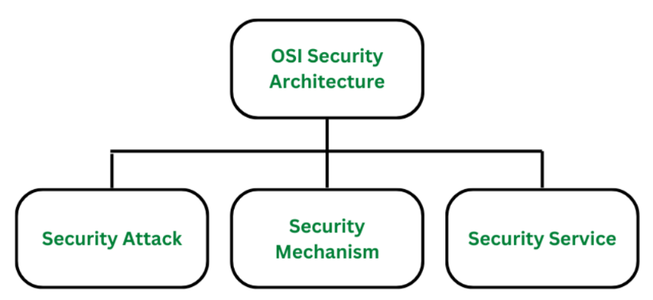
Q. Give short note on HTTPS.
HTTPS (HyperText Transfer Protocol Secure) is the secure version of HTTP, adding an encryption layer (SSL/TLS) to protect data between your browser and websites, like sending a letter in a locked box instead of a postcard, preventing eavesdropping, tampering, and ensuring you're talking to the real site, signaled by a padlock icon. It's crucial for logins, payments, and any sensitive info, encrypting everything from passwords to credit card details, making it the standard for modern, trustworthy web browsing.
In Simple Terms
- HTTP (http://): Unsecured data transfer (like a postcard).
- HTTPS (https://): Encrypted, secure data transfer (like a locked envelope).
How It Works (The Key Parts)
- Encryption (SSL/TLS): Uses Secure Sockets Layer (SSL) or its successor, Transport Layer Security (TLS), to scramble data.
- Handshake: Browser and server exchange keys to establish a secret code.
- Padlock Icon: Your browser shows a padlock in the address bar, confirming a secure connection.
- Port 443: Uses a different port (443) than HTTP (port 80) for security.
Why It Matters (Benefits)
- Privacy: Keeps your data (passwords, credit cards, messages) secret from hackers.
- Integrity: Ensures data isn't changed or corrupted during transfer.
- Authentication: Verifies the website is genuine (not a fake).
- Trust: Builds user confidence and is favored by search engines like Google.
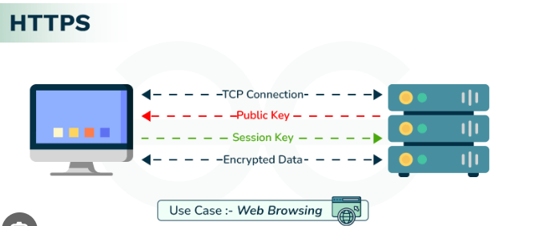
Q. Give short note on IDS.
An Intrusion Detection System (IDS) is like a digital security guard for your computer network, constantly watching traffic for bad guys (hackers, malware) or weird behavior, then alerting you when it finds trouble, rather than stopping it directly. It uses methods like matching known attack patterns (signatures) or spotting unusual activity (anomalies) to flag threats, keeping your systems safer by giving admins a heads-up.

What it is & How it Works (Simple Terms)
- Digital Watchdog: An IDS is software or hardware that "listens" to network traffic, looking for anything suspicious.
- Spotting Trouble: It checks for known virus codes (signatures) or detects when something behaves strangely, like a user suddenly accessing huge files.
- Alerts & Logs: When it finds something bad, it sends an alert (like a siren) to security teams and logs the event, so admins can investigate.
Key Types
- Network-based (NIDS): Watches all traffic flowing across the network.
- Host-based (HIDS): Monitors a specific computer or device (like a server) for internal issues.
How it Detects (Methods)
- Signature-based: Looks for specific "signatures" (patterns) of known attacks, like an antivirus finding a virus.
- Anomaly-based: Learns what "normal" looks like and flags anything that deviates from that baseline.
IDS vs. IPS (Important Distinction)
- IDS (Detects & Alerts): A passive listener; it reports but doesn't stop the attack.
- IPS (Intrusion Prevention System): A more active system that can automatically block malicious traffic once detected.
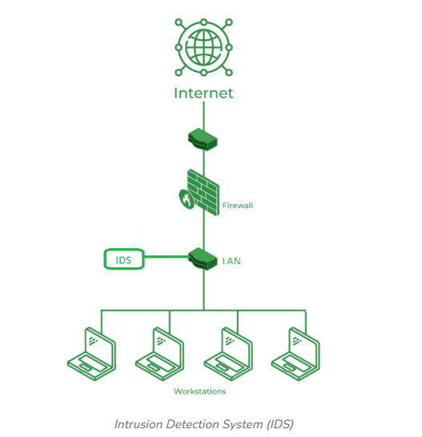

- An IDS (Intrusion Detection System) monitors the traffic on a computer network to detect any suspicious activity.
- It analyzes the data flowing through the network to look for patterns and signs of abnormal behavior.
- The IDS compares the network activity to a set of predefined rules and patterns to identify any activity that might indicate an attack or intrusion.
- If the IDS detects something that matches one of these rules or patterns, it sends an alert to the system administrator.
- The system administrator can then investigate the alert and take action to prevent any damage or further intrusion.

- Classification of Intrusion Detection System(IDS)
Network Intrusion Detection System (NIDS): Network intrusion detection systems (NIDS) are set up at a planned point within the network to examine traffic from all devices on the network.
Host Intrusion Detection System (HIDS): Host intrusion detection systems (HIDS) run on independent hosts or devices on the network. A HIDS monitors the incoming and outgoing packets from the device only and will alert the administrator if suspicious or malicious activity is detected
Hybrid Intrusion Detection System: Hybrid intrusion detection system is made by the combination of two or more approaches to the intrusion detection system .In the hybrid intrusion detection system, the host agent or system data is combined with network information to develop a complete view of the network system.
Application Protocol-Based Intrusion Detection System (APIDS): An application Protocol-based Intrusion Detection System (APIDS) is a system or agent that generally resides within a group of servers.
Protocol-Based Intrusion Detection System (PIDS): It comprises a system or agent that would consistently reside at the front end of a server, controlling and interpreting the protocol between a user/device and the server.
Signature-Based Detection: Signature-based detection checks network packets for known patterns linked to specific threats. A signature-based IDS compares packets to a database of attack signatures and raises an alert if a match is found
Q. Explain model for network security.
A network security model is a layered framework of rules, technologies (like firewalls, encryption), and processes (authentication, authorization) used to protect a network's data and resources from threats, ensuring only authorized users can access them, by scrambling data for transit (encryption) and controlling access points. It works like a fortress with walls (firewalls), guards (authentication), and rules (policies) to keep digital intruders out and protect sensitive info, using techniques like encryption for data in transit and storage.
Simple Explanation (The Fortress Analogy)
Imagine your network is a castle:
- Walls & Moats (Firewalls): Block unwanted visitors (hackers, malware) from getting in.
- Guards & Keys (Authentication/Authorization): Check IDs (usernames/passwords, biometrics) and only let authorized people (users) into specific rooms (resources).
- Secret Codes (Encryption): Scramble messages (data) so if a thief intercepts them, they can't read them; only the intended recipient with the right key can unscramble (decrypt) them.
- Security Policies (Rules): The castle's laws (e.g., no visitors after dark, restricted areas) that everyone must follow.
Key Components Explained
- Security Policies: The "rulebook" defining how security is managed, acceptable use, and compliance.
- Authentication: Verifying who you are (e.g., login, MFA, biometrics).
- Authorization: Determining what you can do once authenticated (e.g., Role-Based Access Control).
- Encryption: Turning data into unreadable code (ciphertext) during transmission (TLS) or storage (AES).
- Firewalls: Software/hardware barriers filtering network traffic based on rules.
- Intrusion Detection/Prevention (IDS/IPS): Monitoring for suspicious activity and blocking threats.
- Trusted Third Parties: Entities (like Certificate Authorities) that help manage keys or verify identities securely.
How It Works (The Sender/Receiver Model)
- Sender: Takes plain text message -> Encrypts with a key (Transformation) -> Sends ciphertext.
- Channel (Network): Hacker might try to intercept.
- Receiver: Receives ciphertext -> Decrypts with the same key -> Gets original plain text.
In short, network security models create layered defenses (Physical, Technical, Administrative) to protect data integrity, confidentiality, and availability from threats like malware and unauthorized access.

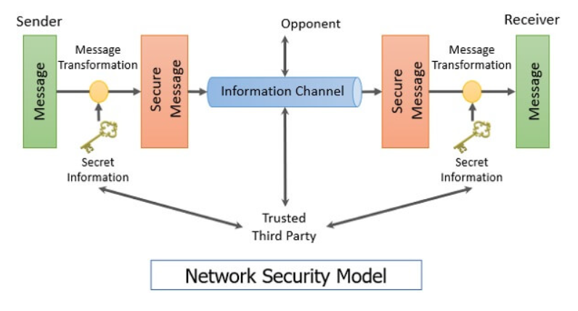
Q. Give short note on Security Policy and mechanisms
In simple terms, a Security Policy is the "what" (rules for safe network use, like "no sharing passwords"), while Security Mechanisms are the "how" (tools and methods, like firewalls or encryption) that enforce the policy, ensuring data confidentiality, integrity, and availability (CIA) by controlling access, protecting data, and managing risks against threats like eavesdropping or hacking.
Security Policy (The Rules)
- What it is: A set of guidelines and rules defining what users and systems can and cannot do on a network to keep it safe.
- Purpose: Protects assets (data, hardware) and people, setting security goals.
- Examples:
  - Acceptable Use Policy: What you can do online at work.
  - Password Policy: Rules for strong passwords.
  - Firewall Policy: Which traffic is allowed in/out.
Security Mechanisms (The Tools)
- What they are: Methods, tools, and procedures used to enforce the policy and protect the network.
- Purpose: Detect, prevent, or recover from attacks.
- Examples:
  - Firewalls: Block unwanted network traffic.
  - Encryption: Scrambles data (like in TLS/SSL) so only authorized users can read it.
  - Access Control: Passwords, PINs, biometrics to verify identity.
  - Intrusion Detection Systems (IDS): Monitor for malicious activity.
  - Backups: A recovery mechanism for lost data.
How They Work Together
- The Policy says, "Only authorized people can see sensitive files".
- The Mechanism (like user accounts, passwords, and access permissions) enforces this rule by requiring a login and checking if you're allowed in.
- It's a layered approach: Policies define the rules, and mechanisms implement them, creating a robust defense
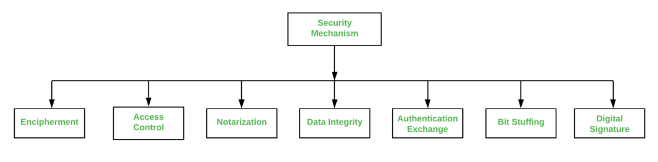
- Encipherment: The process of converting data into a secret code to prevent unauthorized access, ensuring confidentiality. It is often achieved through cryptography techniques.
- Access Control: Mechanisms used to manage and restrict who or what can view or use resources or data.
- Notarization: A service that provides proof of origin, integrity, and time of creation of data, often involving a trusted third party.
- Data Integrity: Ensures that data has not been altered or destroyed in an unauthorized manner, maintaining its accuracy and consistency.
- Authentication Exchange: A process where two entities verify each other's identity before communication or data exchange begins.
- Bit Stuffing: A technique used in data transmission to ensure that specific bit patterns do not appear in the data stream, which could be misinterpreted as control signals.
- Digital Signature: A mathematical scheme for demonstrating the authenticity of digital messages or documents, providing assurance of the sender's identity and data integrity.

Q. Explain Types of Network Attacks.
Network attacks aim to disrupt, steal data, or gain unauthorized access, falling broadly into Active attacks (modifying data, e.g., DoS, MITM) and Passive attacks (monitoring, e.g., sniffing). Key types include Malware (viruses, ransomware), Phishing (social engineering), DoS/DDoS (overloading services), Man-in-the-Middle (intercepting communication), SQL Injection (database attacks), Brute Force (password guessing), and Zero-Day Exploits (using unknown vulnerabilities).
Common Network Attack Types
- Malware Attacks: Malicious software like viruses, worms, Trojans, spyware, and ransomware designed to damage, steal, or disrupt systems.
- Phishing & Social Engineering: Tricking users into revealing sensitive info (passwords, card details) via fake emails or messages.
- Denial of Service (DoS/DDoS): Overwhelming a network or server with traffic to make it unavailable to users (DDoS uses many sources).
- Man-in-the-Middle (MitM): Attacker secretly intercepts and relays messages between two parties, often by spoofing (e.g., Rogue Wi-Fi).
- SQL Injection: Injecting malicious SQL code into web forms to access or manipulate databases.
- Brute Force/Password Attacks: Systematically guessing passwords until the correct one is found.
- Packet Sniffing: Capturing data packets as they travel across a network to steal information.
- Spoofing: Faking source information (IP, email, etc.) to impersonate a trusted source.
- Zero-Day Exploits: Attacking software flaws that are unknown to the vendor, meaning no patch exists.
- Cross-Site Scripting (XSS): Injecting malicious scripts into websites viewed by other users.
Attack Categories
- Passive Attacks: Focus on information gathering (monitoring, sniffing) without altering data, harder to detect (e.g., Eavesdropping).
- Active Attacks: Directly interfere with system resources, altering data or disrupting services (e.g., DoS, malware, unauthorized access).

Q. Explain IPSec in detail.
IPsec (Internet Protocol Security) is a crucial framework of protocols securing, IP communications by adding encryption, authentication, and integrity checks at the network layer, creating secure "tunnels" for data over public networks, commonly used for VPNs to protect sensitive data like financial info and corporate traffic, ensuring confidentiality (unreadable data) and authenticity (correct sender). It uses key protocols like AH (Authentication Header) for integrity and ESP (Encapsulating Security Payload) for encryption, working deep in the stack to secure entire sessions between devices, routers, or networks.

Core Principles & Goals
- Confidentiality: Scrambles data (encryption) so only the intended recipient can read it.
- Integrity: Ensures data hasn't been altered in transit (hashing/authentication).
- Authentication: Verifies the identity of the sender to prevent spoofing.
- Anti-Replay: Prevents attackers from capturing and re-sending packets.
Key Components (Protocols)
- Authentication Header (AH): Provides data integrity and authentication, but not encryption. It ensures packets aren't tampered with and come from the right source.
- Encapsulating Security Payload (ESP): Offers confidentiality (encryption), data origin authentication, integrity, and anti-replay services, often used with encryption.
- Internet Key Exchange (IKE): A protocol to automatically negotiate security parameters (like encryption algorithms, keys) and establish secure connections (Security Associations - SAs) between endpoints.
How It Works (Conceptual Steps)
- Initiation: When "interesting traffic" (defined by policies) flows, devices detect it and start negotiations.
- Authentication: Peers (devices/routers) authenticate each other (e.g., via pre-shared keys or digital certificates).
- Key Exchange (IKE): They agree on encryption/hashing algorithms and generate session keys.
- Tunnel/Transport Mode:
  - Tunnel Mode: Encrypts the entire original IP packet, adding new IP headers, typically used for site-to-site VPNs.
  - Transport Mode: Encrypts only the payload (data part) of the IP packet, used for host-to-host communication.
- Data Transfer: Encrypted packets (ESP/AH headers added) travel across the network.
- Decryption: The receiver uses the agreed-upon keys to decrypt and verify the packet.
Common Uses
- Virtual Private Networks (VPNs): Securing remote access or connecting branch offices over the public internet (Site-to-Site & Remote Access VPNs).
- Secure Cloud Connectivity: Protecting data paths to and from cloud environments.
- Securing Router Communications: Protecting routing protocol updates.
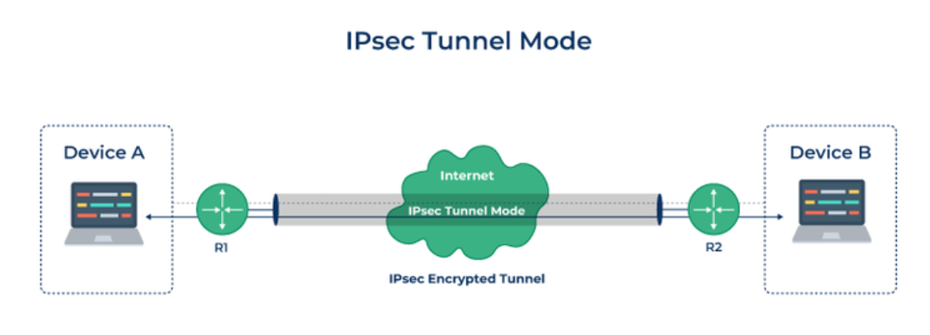
In essence, IPsec brings robust, end-to-end security to the foundational internet protocol, ensuring privacy and trust in digital communication.

Q. List and explain various elements of Information Security
Information Security elements center on the CIA Triad (Confidentiality, Integrity, Availability), ensuring data is private, accurate, and accessible, supplemented by Authenticity (verifying users/data origin) and Non-Repudiation (proving actions occurred), supported by technical controls (encryption, authentication) and processes (risk management, disaster recovery, compliance) across domains like network, application, and cloud security to protect assets from threats.
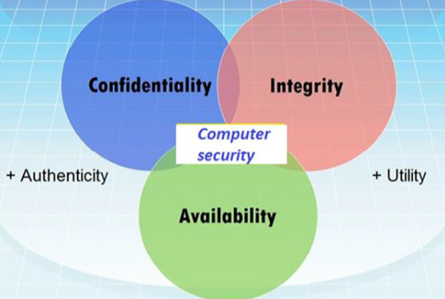
Here are the key elements explained:

Core Principles (CIA Triad)
- Confidentiality: Preventing unauthorized disclosure of information; keeping data private for authorized users only, using methods like encryption and access controls.
- Integrity: Maintaining data accuracy, consistency, and trustworthiness; ensuring data isn't altered improperly (accidentally or maliciously).
- Availability: Ensuring authorized users have timely, reliable access to information and systems when needed, supported by robust infrastructure and backups.
Extended Principles
- Authenticity: Verifying that users, systems, or data are genuine and not impersonated, often through strong authentication methods.
- Non-Repudiation: Ensuring that a party cannot deny having sent or received a message or performed an action, preventing denial of responsibility.
Key Supporting Elements & Domains
- Risk Management: Identifying, assessing, and mitigating potential threats and vulnerabilities.
- Access Control: Defining and enforcing rules for who can access what resources.
- Encryption (Cryptography): Encoding data to make it unreadable without a key, securing communication and storage.
- Authentication: Confirming identities (passwords, biometrics, tokens).
- Network Security: Protecting network infrastructure from breaches.
- Application Security: Securing software and apps from vulnerabilities.
- Cloud Security: Protecting data and systems in cloud environments.
- Disaster Recovery & Business Continuity: Plans to restore operations after a disruption.
- Physical Security: Securing hardware and facilities from physical theft or damage.
- Compliance: Adhering to legal, regulatory, and industry standards (e.g., GDPR, HIPAA).
- Operational Security (OPSEC): Protecting sensitive operational information.
- End-User Security: Educating users to prevent human error (phishing, weak passwords).
Q. Draw and explain Operational Model of Network Security.
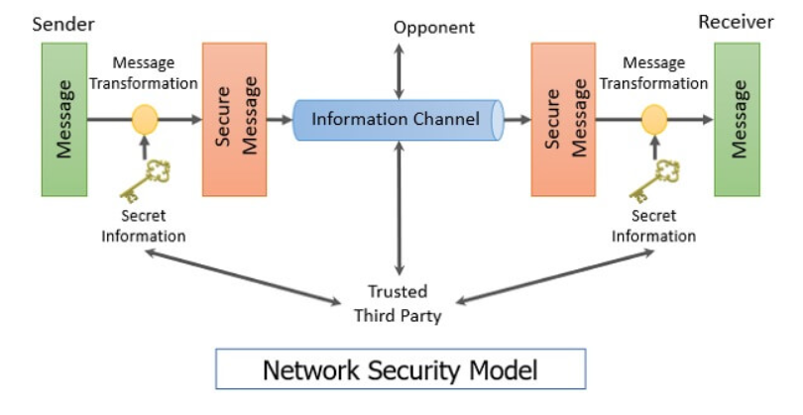
The operational model of network security is a framework for secure data exchange between a sender and receiver over a public network, where the sender encrypts the message into an unreadable format (ciphertext) using a secret key, which is then sent through a vulnerable channel. An opponent can intercept it, but a trusted third party might help securely share the key. The receiver decrypts the ciphertext back to its original plain text using the key. This model relies on encryption algorithms and key secrecy to ensure only authorized parties can access the information.
Explanation of the model
- Sender:
  - Has a message in plain text to send to the receiver.
  - Uses an encryption algorithm and a secret key to transform the plain text into an unreadable ciphertext.
  - This encrypted message is then sent out across the network channel.
- Network Channel:
  - This is the public or insecure pathway for data transmission, like the internet.
  - It is vulnerable to opponents (attackers) who can try to intercept or modify the message.
- Opponent:
  - A malicious entity that attempts to intercept the ciphertext as it travels through the network channel.
  - Without the secret key, the opponent cannot decipher the message.
- Trusted Third Party:
  - An optional but often necessary component.
  - Helps securely distribute the secret key between the sender and receiver, which is a critical step for the security of the entire process. Examples include certificate authorities.
- Receiver:
  - Receives the ciphertext through the network channel.
  - Uses a decryption algorithm and the same secret key to convert the ciphertext back into its original plain text, making it readable again.
Q. Explain Secure Socket Layer handshake Protocol.
The SSL (Secure Sockets Layer) Handshake Protocol is a negotiation process between a client (browser) and a server to establish a secure, encrypted connection for data exchange, ensuring privacy, integrity, and authentication using digital certificates and agreed-upon encryption keys (cipher suites). It works in four main phases: Hello (negotiate SSL version/ciphers), Certificate Exchange (server sends cert, client verifies), Key Exchange (client encrypts secret with server's public key), and Finished (confirm setup), allowing them to securely exchange sensitive data like logins or payments.
Key Goals of the Handshake
- Authentication: Verify the server's (and optionally, client's) identity using digital certificates.
- Encryption: Agree on algorithms (cipher suites) to scramble data.
- Key Exchange: Securely generate and exchange session keys for symmetric encryption.
The Four Phases Explained
- Client Hello: The client initiates by sending supported SSL/TLS versions, cipher suites (algorithms), and random data.
- Server Hello & Certificate: The server responds, choosing the best SSL version/cipher, sending its digital certificate, and its public key.
- Client Authentication & Key Exchange: The client verifies the server's certificate, generates a secret (pre-master secret), encrypts it with the server's public key, and sends it.
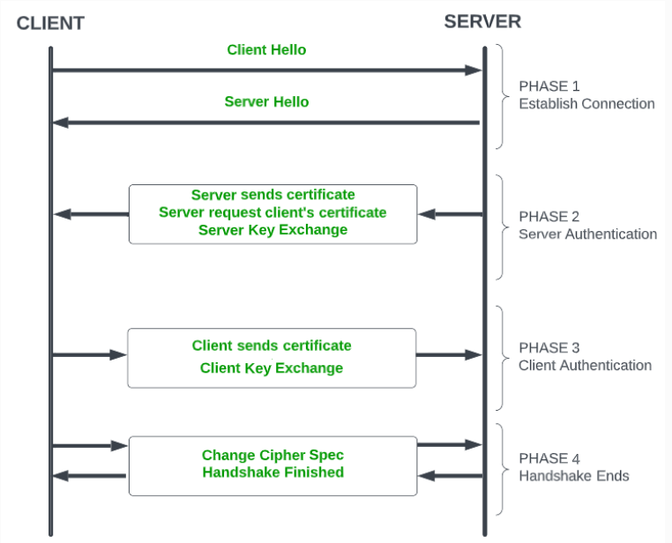
- Key Generation & Finished: Both parties use the exchanged data to create identical symmetric session keys for fast data encryption, then send "Finished" messages to confirm successful setup.

Outcome
After the handshake, the connection switches from asymmetric (public/private key) to symmetric (session key) encryption, allowing for fast, secure, and private communication (HTTPS).
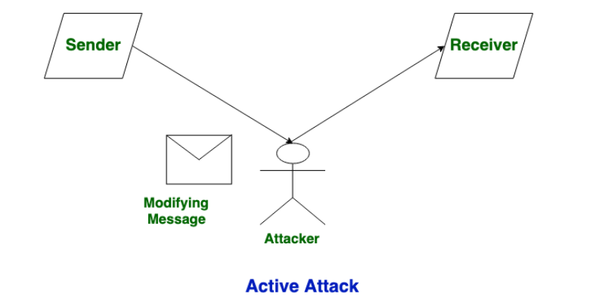
Q. Differentiate between Active attacks and Passive Attacks.
